**DEV/LVLUP**

With the GitHub Student Developer Pack, I installed BootStrap Studio. Bootstrap is something that I’ve seen referenced on the web a lot, but have never been exposed to it.

What is it?

Bootstrap studio is a web design tool that offers components to help build responsive pages. It lays out code visually so that you can see what you are changing without having to adjust the code every single time. This reduces the trial and error part of laying out a website.

Steps I took.

After installing Bootstrap Studio, I started with a new design. 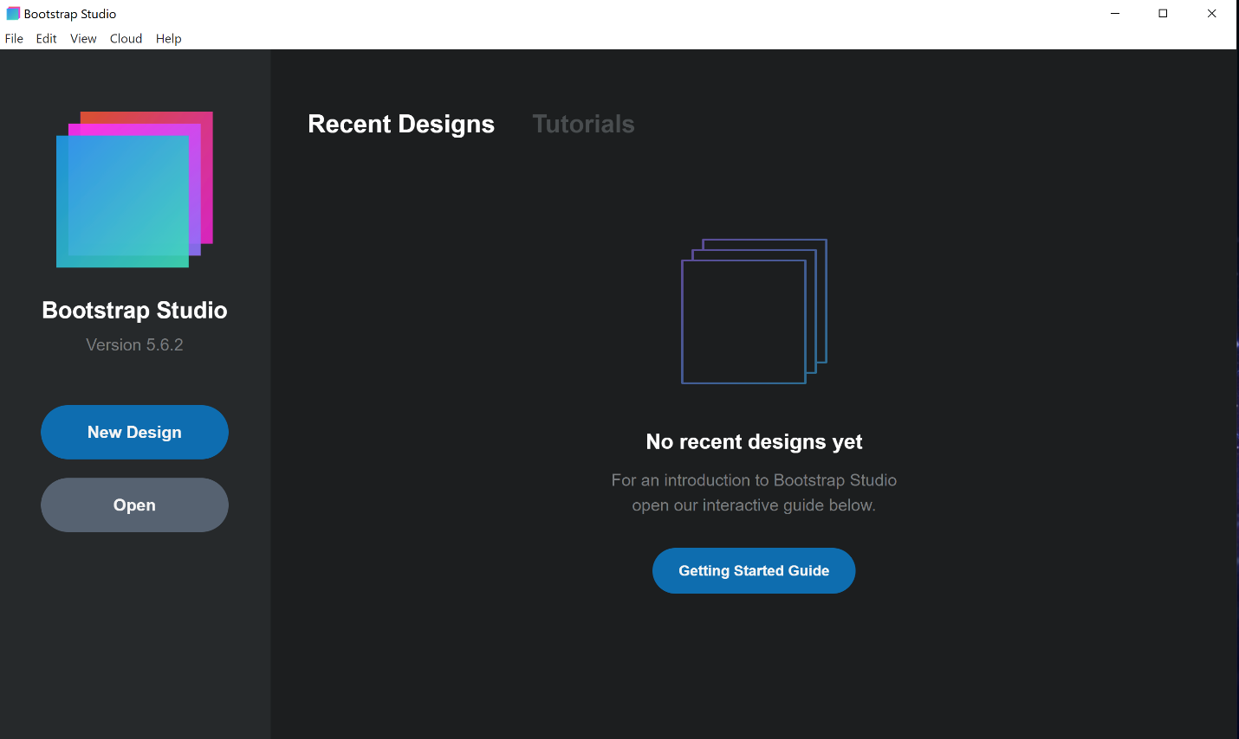

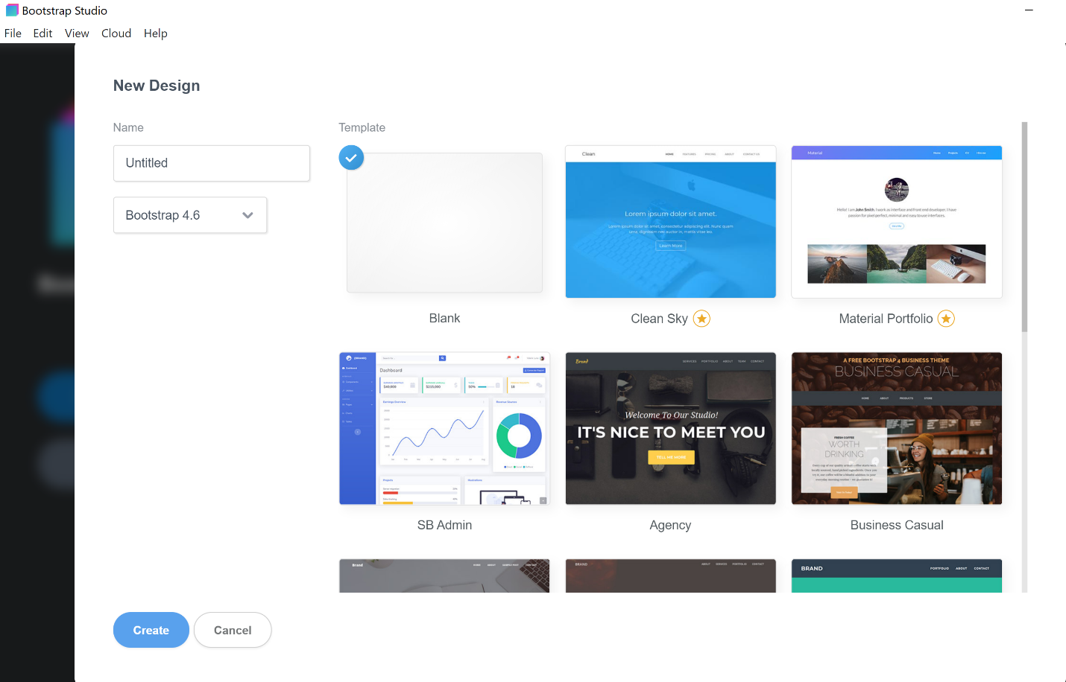

I was offered a bunch of starter templates to help get myself started on a webpage. The one I chose included 4 pages, but I deleted one to fit my needs.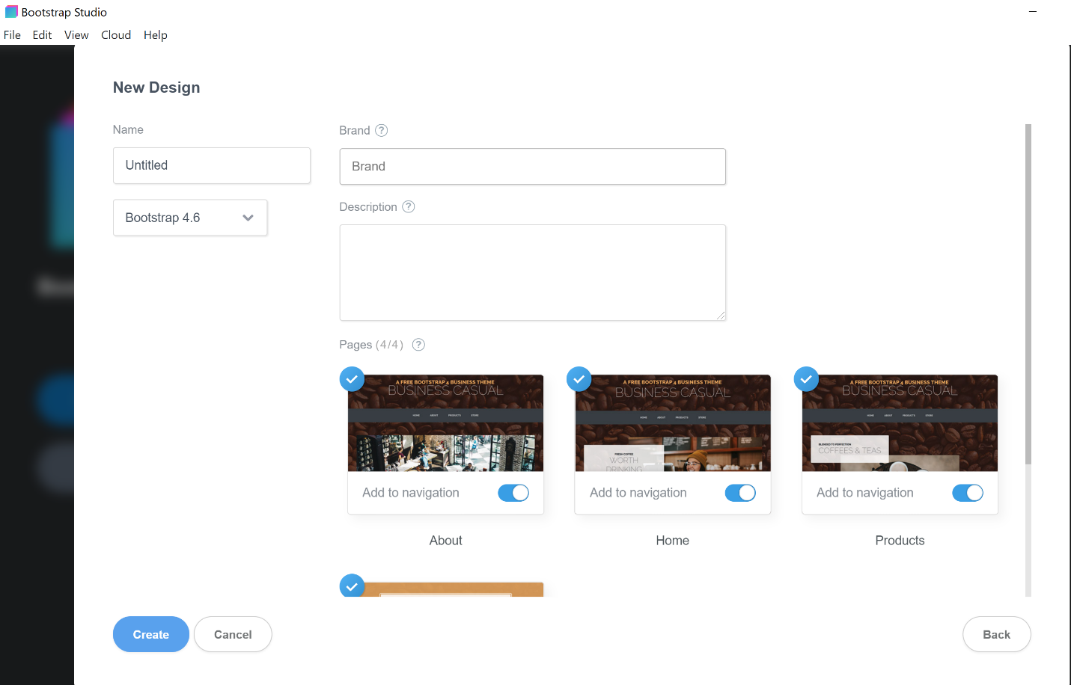

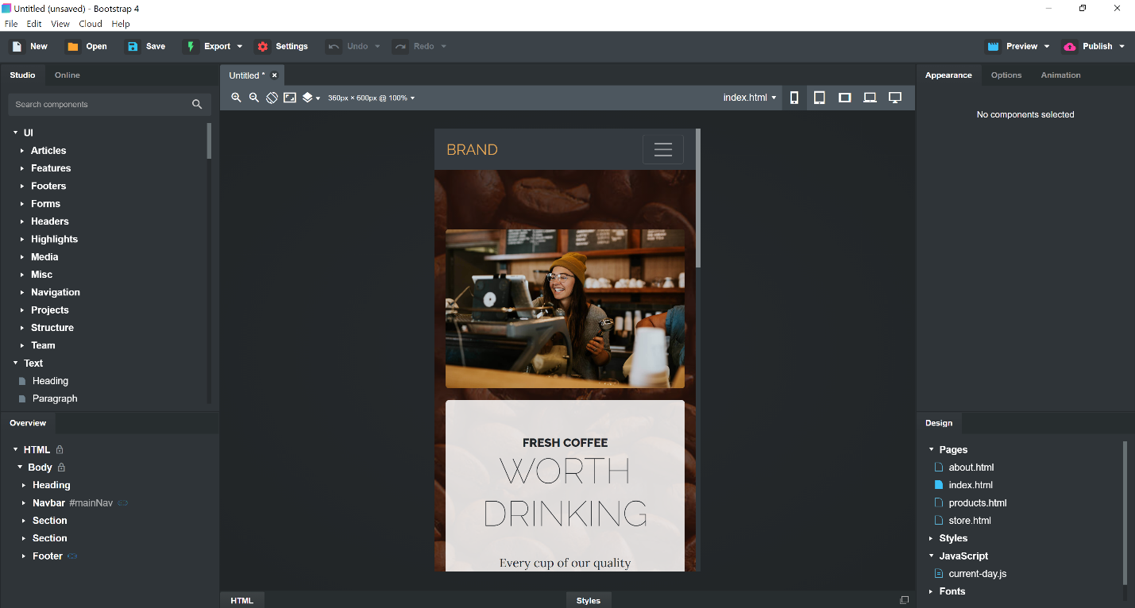

After creating the template, it shows you all the customization options for the selected property. I selected a “div” class and I was allowed to use a UI to customize the properties of the class.

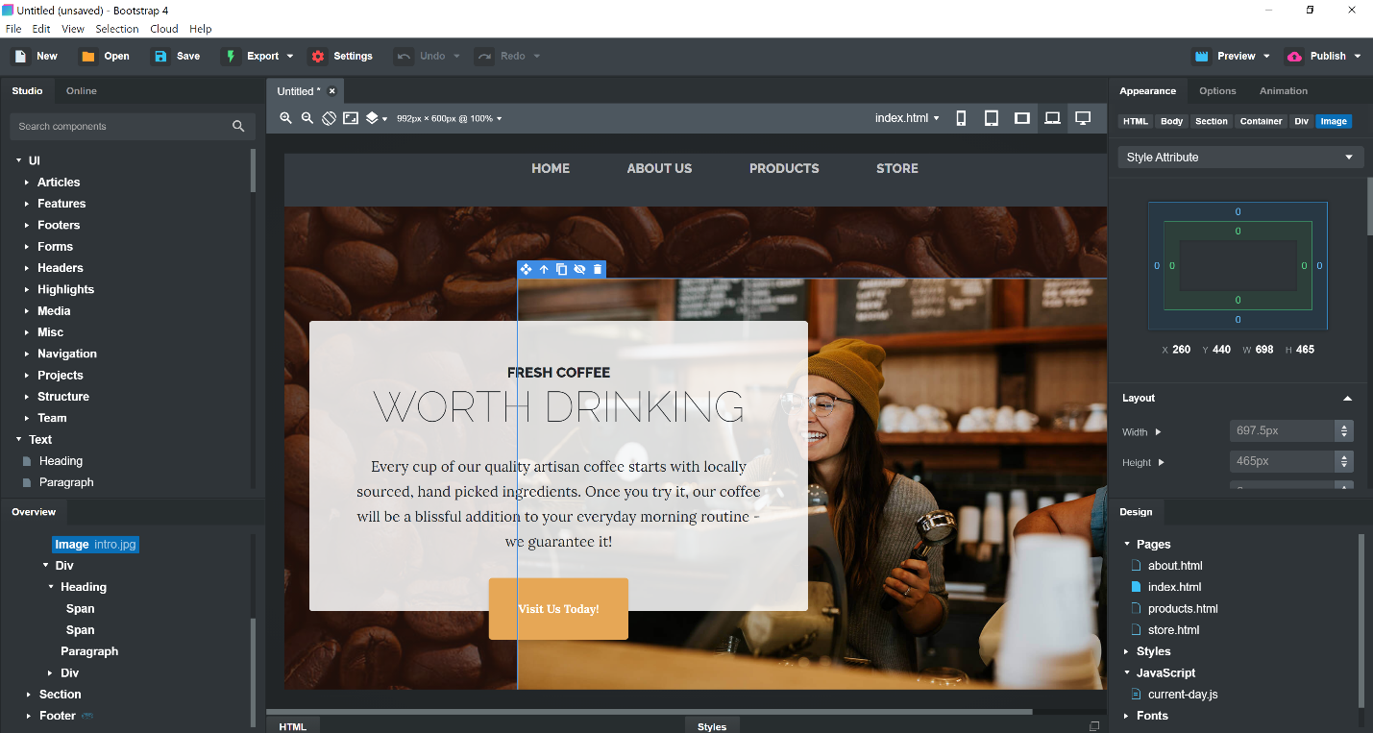

After lots of customization and tooling around, I am left with the final product which looks something like this…

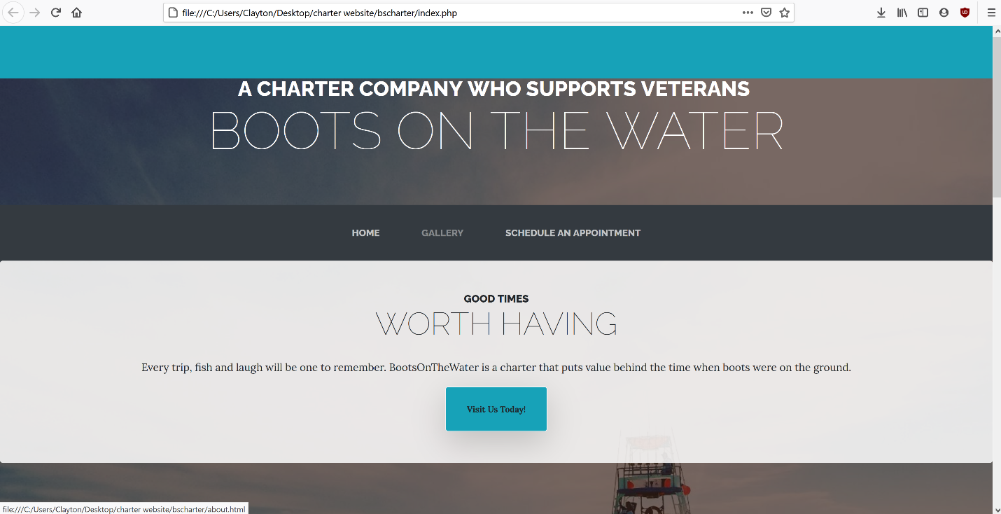

Here is a live link to the page.

https://bscharter.herokuapp.com/